[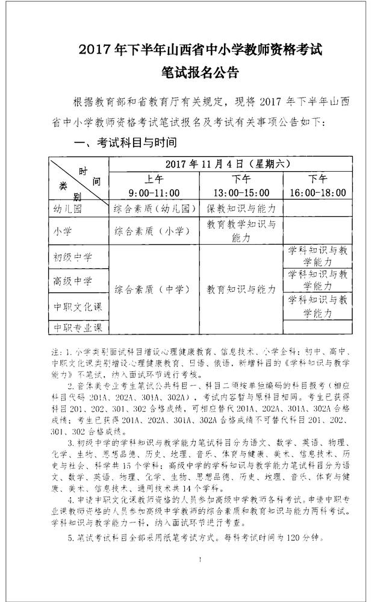](http://cdn-portal-img.30edu.com.cn/37ad60e9-5374-40d6-b87a-087b9b308566/20170811/FuyE3FngjvJ8-xOOoWjFtYA3clIy.jpg" \t "C:/Users/Administrator/AppData/Local/Temp/360zip$Temp/360$1/网络编辑器9.23下载/htmleditorr/edit/_blank)

[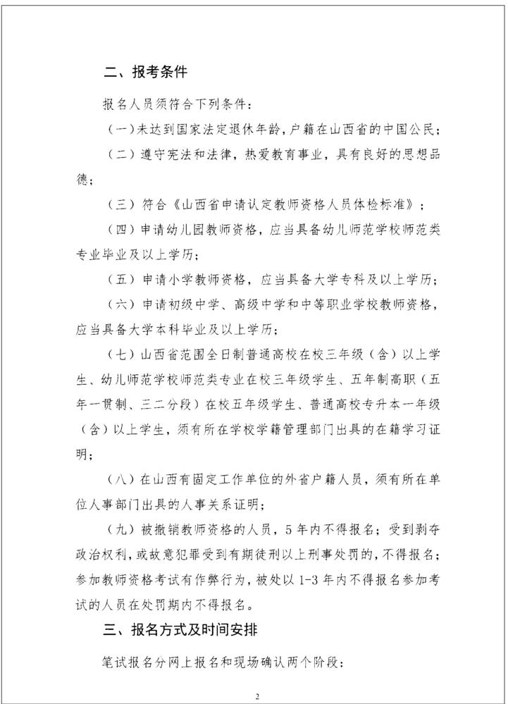](http://cdn-portal-img.30edu.com.cn/37ad60e9-5374-40d6-b87a-087b9b308566/20170811/FvdBuUtvAJPVsYbOW8UnaEjTi80H.jpg" \t "C:/Users/Administrator/AppData/Local/Temp/360zip$Temp/360$1/网络编辑器9.23下载/htmleditorr/edit/_blank)[](http://cdn-portal-img.30edu.com.cn/37ad60e9-5374-40d6-b87a-087b9b308566/20170811/Fmn2qS9207v3MRm-OwBkMWlAPCB6.jpg" \t "C:/Users/Administrator/AppData/Local/Temp/360zip$Temp/360$1/网络编辑器9.23下载/htmleditorr/edit/_blank)

[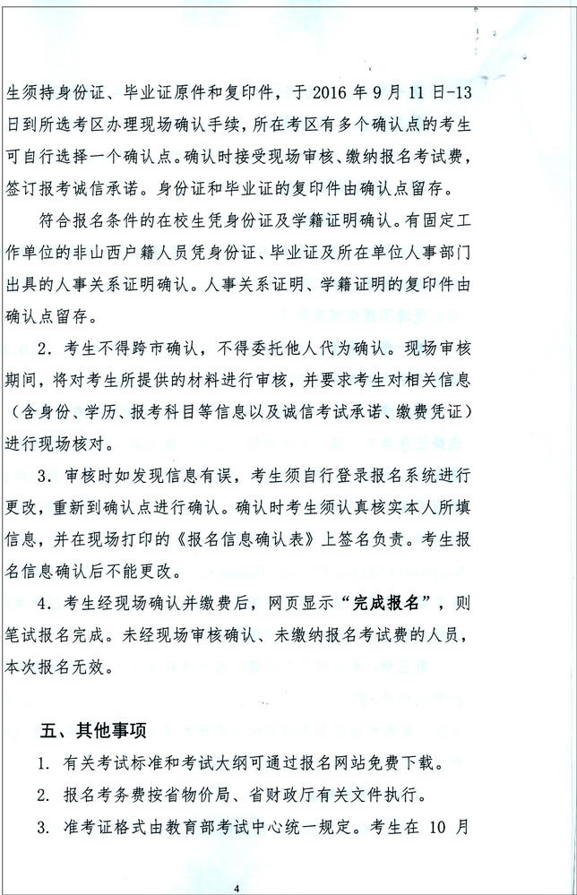](http://cdn-portal-img.30edu.com.cn/37ad60e9-5374-40d6-b87a-087b9b308566/20170811/FhztGYkupiXINqtXjjlDO58927_A.jpg" \t "C:/Users/Administrator/AppData/Local/Temp/360zip$Temp/360$1/网络编辑器9.23下载/htmleditorr/edit/_blank)

[](http://cdn-portal-img.30edu.com.cn/37ad60e9-5374-40d6-b87a-087b9b308566/20170811/FskHqxHHtcWQnQXPu_g8gQl2UPSc.jpg" \t "C:/Users/Administrator/AppData/Local/Temp/360zip$Temp/360$1/网络编辑器9.23下载/htmleditorr/edit/_blank)

[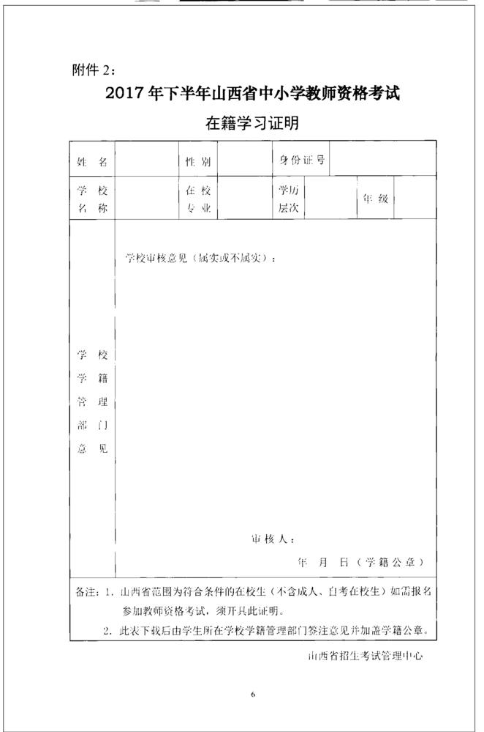](http://cdn-portal-img.30edu.com.cn/37ad60e9-5374-40d6-b87a-087b9b308566/20170811/FsqBQs5kILXzKg50io7VOuqVJRlJ.jpg" \t "C:/Users/Administrator/AppData/Local/Temp/360zip$Temp/360$1/网络编辑器9.23下载/htmleditorr/edit/_blank)